ATLAS Contribution
We kindly ask you to contribute to the Atlas by filling out this document with relevant cases or solutions from your experience, completing as many sections as possible. Your input will help build a rich, diverse collection of practical examples that can support others and strengthen our shared knowledge base.
- A Solution is a tested and replicable method, such as a policy, toolkit, or digital tool, designed to strengthen communication, participation, and coordination in DRR/DRM.
- A Case is a real-world example of civic engagement in DRR/DRM. It tells the story of a specific local action, detailing the challenges faced, steps taken, and results achieved.

Choose how to contribute to the Atlas platform
Solution Case Not Sure
Title
Paré pas Paré (Ready or not)

Overview
The Paré pas Paré project is an educational programme in Réunion Island designed to increase awareness of natural hazards and teach safe behaviors before, during, and after disasters. Activities are carried out within schools, integrated into the curriculum, and through extracurricular initiatives such as competitions, interactive games, prevention stands, and field trips. The programme targets students aged 8–12.
Upload Picture [attach a picture of the solution/case]
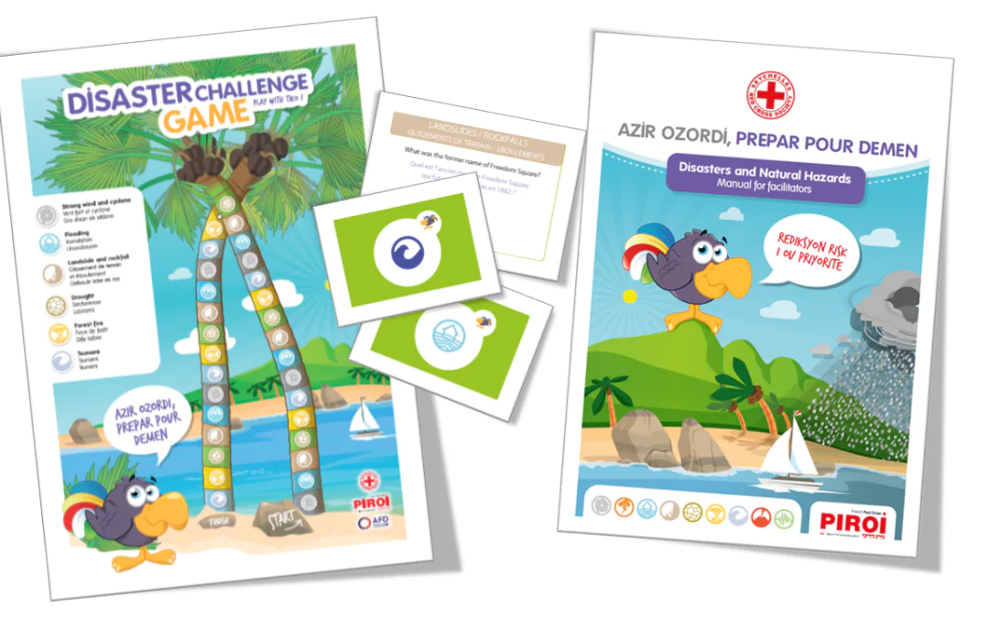

Section: General Information
Summary Description
Disaster preparedness educational programmes for children and youth
Context & Background [explain the situation, risk, or challenge that led to the creation of this solution/case]
The Réunion Island is located in the Indian Ocean, making it particularly vulnerable to powerful cyclones that bring destructive winds and torrential rains, often followed by flooding in rivers and low-lying areas. The steep volcanic terrain, combined with heavy rainfall, frequently causes landslides that threaten villages and infrastructure, while the active volcano Piton de la Fournaise poses additional risks through eruptions, lava flows, and ash emissions. Seasonal forest fires endanger biodiversity and communities living near natural reserves, and although earthquakes are generally moderate, the island’s volcanic nature means seismic activity can still cause significant damage and trigger landslides. Finally, as a coastal territory, Réunion is also exposed to tsunamis generated by distant undersea earthquakes, a rare but potentially devastating threat.

Country of the Solution/Case
France

Contributor [person or organization submitting the solution/case]

Status [track the progress of the solution]
Idea In Progress Published
Purpose [define the core function of the solution, such as coordination, preparedness, or risk reduction]
guidelines, technologies training_capacity_building services methodologies tools lessons_learned/practical_example research_and_reports
Topic for Preparedness
early_warning misinformation/disinformation crowdsourcing social_media influencers crisis/risk_communication vulnerability_assessment. community_engagement spontaneous_volunteers

Section: Needs Addressed
Hazard Type
xearthquakes x tsunamis x volcanic_eruptions x floods, storms_and_cyclones droughts. heatwaves x wildfires x landslides pandemics_epidemics industrial_accidents transportation_accidents terrorism cybersecurity_threats xmulti_hazard refugee_crisis social_support missing_person
Geographical Scope NUTS
x NUTS 1 (Macro-region) NUTS 2 (Region) NUTS 3 (Province) NUTS 4 (Municipality)
Geographical Scope
urban periurban rural coastal mountainous
Population Size
5.000 5.000_50.000 50.000_200.000 >200.000
Population Density
low_spread_out medium high_crowded
Problem Addressed [explain the situation, risk, or challenge that led to the creation of this solution]
Inhabitants in Réunion Island, including children, are exposed to 7 different types of natural hazards. The island is particularly threatened by cyclones, landslides, flooding, volcanic eruptions, forest fires, seismic activity, and tsunamis. An unstable living environment in Reunion Island can decrease children’s confidence in tomorrow and negatively affect their mental health.

Vulnerable Groups [identify the social groups that require special attention in the implementation of the solution/case]
elderly children people_with_disabilities migrant_population
Vulnerable Groups [additional explanation on the vulnerable groups involved]
Students aged 8 to 12 years old, corresponding to Cycle 3 in the French education system, participate in the educational programme on Réunion Island. In terms of school grades, this includes CM1 and CM2 (the last two years of primary school) and 6ᵉ (the first year of middle school, or collège).
Governance [describe the governance structure of the area where the solution/case is implemented]
centralised decentralised x multistakeholder community_led
Governance [additional insights into governance models and roles]
Réunion’s governance is primarily centralized with decentralized elements, functioning as a multi-stakeholder system where central authorities, local councils, schools, NGOs, and communities collaborate, though key decisions remain guided by the state.
Emergency Preparedness [assess the level of preparedness in the target area]
no_drm_plan basic_preparedness organised_response x advanced_preparedness
Emergency Preparedness [additional explanation of preparedness strategies in place]
Réunion has well-established and advance emergency preparedness system. Early warning mechanisms and public awareness programmes help residents prepare for the natural-hazards.
Infrastructure Readiness [evaluate the level of infrastructure available for disaster response]
none basic x developed advanced_resilient
Infrastructure Readiness [additional details on the infrastructure situation]
Critical facilities like hospitals, schools, and evacuation centers are well-developed, but the Réunion’s steep terrain and exposure to multiple hazards create ongoing challenges, especially for remote communities. Continuous investment and community engagement remain essential to maintain resilience.

Engagement Level [define the extent to which stakeholders participate in the solution]
Information (Low - Low) - One-way communication; citizens are informed of decisions or processes but have no direct input.
X Dialogue (High - Low) - Two-way communication; stakeholders are interested in engagement but may not yet be seen as central actors.
Consultation (Low - High) - Authorities actively seek input from stakeholders who may not be highly mobilised but are key to the process.
Partnership (High - High) - Shared responsibility and co-decision-making; stakeholders co-create and co-own solutions with public authorities

Purpose of Engagement [clarify the role and objectives of stakeholder involvement]
The programme aims to:
a) Raise students’ awareness of natural disaster risks.
b) Teach appropriate behaviors to adopt before, during, and after disasters.
c) Collaborate with local authorities to organize community-based preparedness and natural risk prevention activities.
Methods of Engagement [list techniques used to engage stakeholders (e.g., participatory workshops, advisory boards]
The programme engages students through interactive booklets, games, comics, storybooks, competitions, and prevention activities, combining hands-on, visual, and social methods to teach safe behaviors before, during, and after natural hazards.
Empowerment Level [measure how much decision-making power is given to stakeholders]
Awareness - Communities are informed of DRRM strategies and understand their importance.
x Understanding - Communities engage in dialogue and acquire knowledge to interpret and reflect on DRRM choices.
Involvement - Communities provide input that is considered in planning and action.
Collaboration - Communities share responsibility and decision-making power throughout the process.

Degree of Influence & Decision-Making [describe how participants influence decisions in the solution/case’s design and implementation]
Through modules, games, comics, and interactive activities, children and youth acquire knowledge, interpret risks, and consider appropriate actions. This gives them a moderate degree of influence in decision-making: while final policies or technical measures are set by authorities, students can shape their own preparedness behaviors, influence school-level safety practices, and provide insights that inform broader community awareness.

Capacity-Building & Long-Term Empowerment [explain how the solution/case increases long-term resilience and decision-making capabilities]
Engaging children and youth in these education programme strengthens long-term resilience by helping them understand the area where they live and the hazards specific to it, develop practical skills, and build confidence in making informed decisions. Through active participation, they adopt a culture of preparedness and can influence safety practices within their schools and communities, creating a lasting impact on both personal and collective resilience.

Section: Implementation
Key Features & Innovations [highlight the unique aspects and innovations that differentiate this solution/case]
The educational programme was integrated in the official curriculum of the La Reunion. The programme is supported through specific booklets and learning materials, where natural hazards carachterised the island are describe and also behaviors to have before during and after natural hazards. Spaces spaces for students’ obeservations and thoughts are includeded as extra-curriculum activities togheter with exercies and games. Besides these modules, the project had developed also:
- The board game “Risk Peï” links each square to questions about Réunion’s environment, hazards, protection measures, and historical events.
- Harry Trotter postcards feature a virtual character who asks hazard-specific questions to prompt reflection.
- Comics explain the seven main hazards and the correct measures to take before, during, and after each event.
- The serious game “A zot et les zinondations” focuses on correct behaviors related to floods.
- Posters provide prevention instructions in a comic-strip format.
- The animated storybook “The Island of 1000 Dangers” introduces preparation and prevention measures for five key hazards.
- Natural hazard model competitions engage cycle 3 students in creating models of events like volcanic eruptions or landslides, with top classes winning field trips to technical partners.
- Prevention activities in schools and prevention villages allow students aged 6–17 to participate in awareness games organized by trained French Red Cross volunteers.
Language(s) [list the languages in which the solution/case is available]
French

Implementing Org [specify the organization(s) responsible for managing and deploying the solution/case]
The educational programe is created jointly by the French Ministry of Education, French Red Cross’s (FRC), Indian Ocean Regional Intervention Platform (PIROI) and their technical partners.

Experience of Implementing Org in DRM [assesses the level of expertise in DRM of the implementing organisation]
x High Medium Low
Experience of Implementing Org in DRM [provide additional details on the organization's experience in DRM]
• French Ministry of Education: Provides expertise in educational program design, curriculum integration, and child-focused learning, ensuring DRM content is age-appropriate and pedagogically sound.
• French Red Cross (FRC): Brings practical experience in humanitarian response, community preparedness, volunteer mobilization, and training in first aid and disaster response.
• PIROI (Indian Ocean Regional Intervention Platform): Offers regional expertise in natural hazards specific to the Indian Ocean area, coordination of multi-agency DRM interventions, and field-tested tools for preparedness and response.
• Technical partners: Provide specialized knowledge on environmental hazards, monitoring, early warning systems, and scientific guidance to inform both educational content and community preparedness strategies.

Actors Involved [list key stakeholders contributing to the solution/case’s implementation]
PIROI-FRC trained volunteers intervene directly in the target schools to animate the booklet developed with the French Ministry of Education in Reunion Island on natural hazards and indications on what to do in the event of a disaster and additional resources. From 2020 onwards, teachers from schools are trained on DRR by PIROI-FRC staff and volunteers run the sessions within their academic curricula.

Implementation Steps [describe the sequence of actions needed to implement the solution/case]
The educational program takes place through 3 school years. CM1/4th grade students in public and private schools receive each year a printed student booklet which will follow them until 6th grade. In CM1, students focus on general natural disaster risks module, and cyclones and landslides modules, in CM2 on flooding, volcanic eruptions, forest fires modules, in 6e on seismic activity,and tsunamis module. To further increase knowledge and awareness of the natural disaster risks, the booklet is accompanied by interactive local risks board game “Risk Peï” and Harry Trotter postcards. To further learn about the correct behavior before, during, and after natural disasters, comics, serious game, posters, and an animated storybook are used. To strengthen students’ engagement in this learning, PIROI-FRC staff and volunteers organizes each year during the extra-curricular time in schools. For instance, a natural hazard model (e.g. volcanic eruption or landslide) competitin open to all cycle 3 students and prevention activities in schools and prevention villages.

Resources Required [identifies broad categories of required resources (e.g., human, financial, technical]
none limited_external stable_local x sustainable_int_ext_mix
Resources Required [detail specific resource needs for implementation]

Implementation requires educational materials (booklets, games, comics, posters, digital storybooks, and competition supplies), trained personnel (teachers, volunteers, technical partners), digital tools (computers, tablets, projectors, software), and logistical support (classrooms, activity spaces, transportation, storage, printing, and communication) to deliver interactive and engaging natural hazard education.
Timeframe & Phases [define the expected timeline for implementation]
None Basic Strategy Structured Framework Comprehensive and Monitored
Timeframe & Phases [additional details on implementation phases]

The programme began in 2011 with the development of learning materials and pilot school activities. From 2020 onwards, teachers are trained by PIROI-FRC to deliver Disaster Risk Reduction lessons within the curriculum, complemented by extracurricular activities and interactive learning.
Target Audience [list key stakeholders contributing to the solution/case’s implementation]
x government_agencies x emergency_services x civil_society_and_local_actors researchers private_sector_and_economy general_public x educational_institutions media_and_communication policy_makers xinternational_organisations military_infrastructures/facilities

Section: Partecipation Result
Challenges & Adaptive Strategies [identify implementation challenges and how they were overcome]
Specific information on challenges and adaptive strategies are not public available. General challenges in implementing an edicaitional program lke this could be:
- Fitting the program into already full school schedules can be difficult, especially when balancing core subjects with extracurricular activities. For this reason, the educational programme has been officially included in the school curriculum, ensuring that the main topics on natural hazards are systematically covered while also allowing the possibility of extracurricular activities to reinforce learning
- Ensuring all students actively participate can be challenging, especially for those less interested or with learning difficulties. Therefore, creative and interactive learning materials have been developed to engage every student and make the content more accessible and enjoyable.
- Continuing the program over time requires ongoing funding and regular updates to materials and activities. Therefore, strong institutional support is essential, alongside technical expertise, to maintain the quality, relevance, and effectiveness of the educational programme.

Risk & Mitigation Plan [list common risks and mitigation strategies associated with the solution/case]
none general_preparedness targeted_adaptation multi_hazard_strategy
Risk & Mitigation Plan [additional information on specific risk management measures]
In each grade, knowledge assessment with a survey of 10 questions is done before and at the end of the intervention to quickly measure the impact of awareness-raising activities on a class.
Correspondence of education kit provided by PIROI-FRC to the official French Ministry of Education curriculum for cycle 3. Teachers run the sessions within their academic curricula.
Lessons Learned [key takeaways from implementation efforts]
The strengths of this educational program are reality of knowledge (children live often what they are listening), existence of study materials in various forms adapted to target child population, training and supporting resources for teachers implementing the program, and correspondence of education kit provided by PIROI-FRC to the official French Ministry of Education curriculum for cycle 3.

Section: Scalability & Adaptability
Sustainability Model [explain how the solution/case is maintained over time, including financial, governance, or operational aspects]
Following the educational programme, students have shown measurable improvements in knowledge and preparedness for natural hazards. These gains highlight the programme’s effectiveness in teaching safe behaviors, increasing awareness of local risks, and reinforcing disaster-ready attitudes, thanks to its well-managed governance, resources, and integration into the school curriculum.
The Paré pas Paré programme has been successfully maintained over time through sustained operational and financial support. Since its launch in 2011, the programme has reached more than 200,000 students, a significant portion of Réunion’s population of under 900,000, demonstrating both its scale and continuity. Its long-term maintenance relies on a combination of institutional support, structured governance, and partnerships with organizations such as PIROI-FRC and the French Red Cross, which provide technical expertise, volunteer coordination, and operational oversight.
Scalability & Adaptability [describe whether and how the solution/case can be applied in different contexts]
The Paré pas Paré project is scalable because its core materials—printed booklets, interactive games, comics, and storybooks—can be reproduced and adapted for other schools or regions. It is scalable through flexible delivery, using classroom lessons, extracurricular activities, and community events, and through partnerships with local authorities and NGOs, which provide a model for replication in similar educational and hazard contexts.
Technology & Innovation [evaluate the role of technology in this solution/case]
none limited x developed smart_adaptive_solutions
Technology & Innovation [additional insights into technological components]
Technology and innovation in this project are therefore less about digital tools and more about creative and interactive educational design. The innovative aspect lies in how learning is made hands-on, engaging, and participatory: students learn through playing games, completing challenges, and interacting with physical models of hazards, which helps them understand complex concepts and practice safe behaviors in a tangible, memorable way.

Financial & Logistical Sustainability – Direct Costs [breakdown of direct costs required for implementation]
The specific cost for the Paré pas Paré project is not publicly disclosed.
Financial & Logistical Sustainability – Operational Costs [description of recurring operational costs]
The specific cost for the Paré pas Paré project is not publicly disclosed.

Financial & Logistical Sustainability [assess whether the solution/case has a sustainable funding and operational model]
none shortterm_external stable_local selfsustaining_resilience_approach

URLs / Documents [provide external references, reports, or additional documentation]
https://piroi.croix-rouge.fr/pare-pas-pare/

